

**PRICE LIST – FINE ART PRINTS**

**GREETING CARDS (5x7” Card)**

Single Card **= $4.50 each**

5 Cards= **$20 ($4 each)**

10 Cards = **$35 ($3.50 each)**

**PRINTS ONLY**

8x12” (20cm x 30.5cm) = **$26**

12x18” (30.5cm x 46cm) = **$45**

16x24” (40.5cm x 46cm) -= **$61**

20x30” (51cm x 61cm) = **$75**

*Please note all prices are for prints on Lustre paper, other paper types such as metallic, matte smooth and matte textured are available on request, email for prices

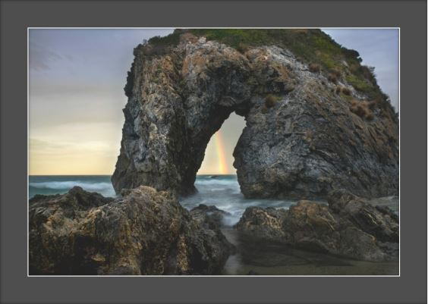

**MOUNTED PRINTS**

8x12” (20cm x 30.5cm) = **$62**

12x18” (30.5cm x 46cm) = **$89**

16x24” (40.5cm x 46cm) -= **$116**

20x30” (51cm x 61cm) = **$150**

**Please note all prices are for prints on Lustre paper, other paper types such as metallic, matte smooth and matte textured are available on request, email for prices

**FRAMED PRINTS**

12x18” (30.5cm x 46cm) = **$170**

16x24” (40.5cm x 46cm) -= **$241**

20x30” (51cm x 61cm) = **$302**

*Please note all prices are for prints on Lustre paper, professionally framed with Perspex, this is to avoid glass breakage during postage. Perspex is lighter than glass and more durable. Glass can be used on request. Other print papers can also be used.

**Prices are for standard black and white wooden frames

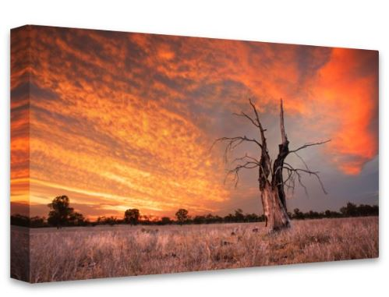**CANVAS**

8x12” (20cm x 30.5cm) = **$85**

12x18” (30.5cm x 46cm) = **$124**

16x24” (40.5cm x 46cm) -= **$150**

20x30” (51cm x 61cm) = **$194**

30x45” (76cm x 114cm) = **$325**

*Prices are for standard box mount canvas, canvases can be ordered with a frame, additional costs will apply

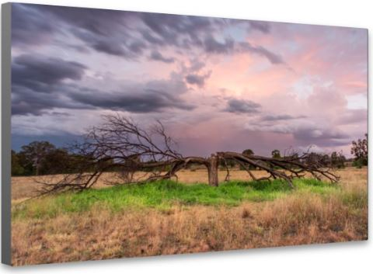**ACRYLIC GLASS PRINTS**

8x12” (20cm x 30.5cm) = **$59**

12x18” (30.5cm x 46cm) = **$110**

16x24” (40.5cm x 46cm) -= **$170**

20x30” (51cm x 61cm) = **$237**

30x45” (76cm x 114cm) = **$468**

**HD ALUMINIUM – FLOAT MOUNT**

8x12” (20cm x 30.5cm) = **$150**

12x18” (30.5cm x 46cm) = **$231**

16x24” (40.5cm x 46cm) -= **$411**

20x30” (51cm x 61cm) = **$516**

30x45” (76cm x 114cm) = **$861**

*Prices are for standard float mount, aluminium prints can be boxed or framed for additional costs

**\*\*Prices do not include postage. Postage will be calculated per order**